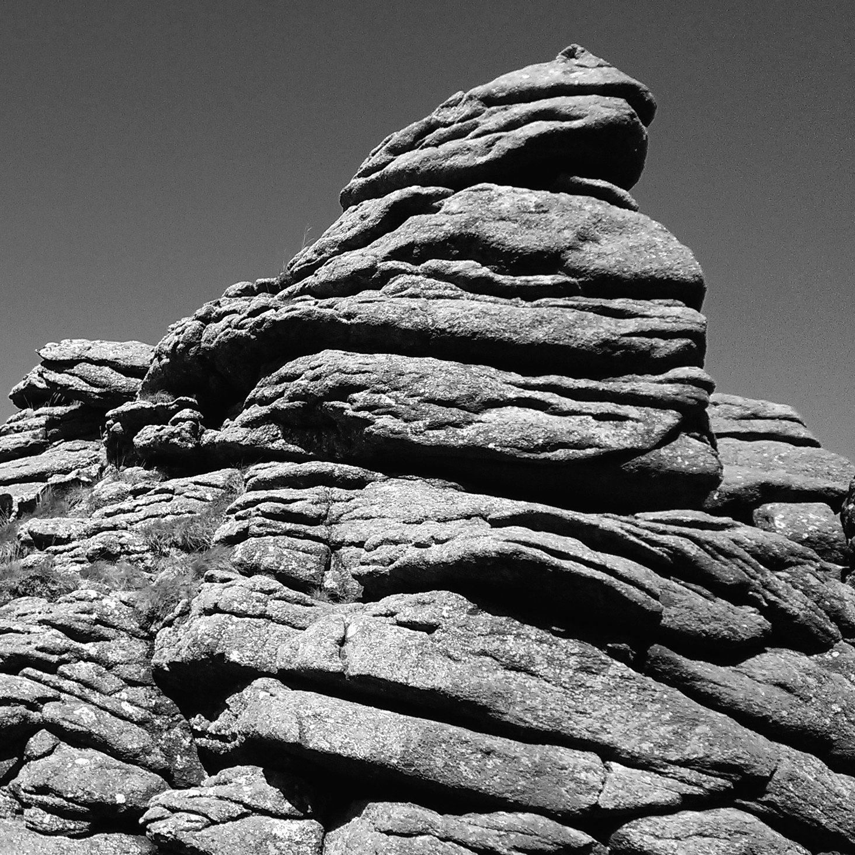

**Null Horror**

Brandon Roman

01. Dartmoor; *Othello*

02. London; Exeter Book riddles and *Capital*

03. Paris; *Nineteen Eighty-Four*

04. London II; *’Tis Pity She’s a Whore*

05. Bath; *Persuasion*

06. Exeter

**01**

I ate flat chocolate on the way and then I saw the big stones stacked like girders. For my father or for any reason I got really pumped and spun my phone round in a circle. The near girl walked near me. So, her head was three, four times in the photo, stacked like girders.

Those old book laws, you know, they say something sinister huffs around here. Their monster’s more like a clue. What do they say?—It’s in its nature to be black, to issue lightning, to rend breath, to, uh, to always end up being what you’ve sensed it was. A dog, is what it was. “That’s the wrong story,” said the near girl, who is an undull and prosperous friend whose counsel is sought after. Still, today was for my revelations, and I snubbed her.

Because when alone one is in contest with oneself, I made to climb next to the boy who neared. There was something of an air of liaison in the approach, and I thought, all rights reserved, that men should be what they seem. It’s true I had some passionate prose levied against him. So, I’m avoiding the point: we scaled different spots and I sized him up in silhouette. He was big black in the sky and breathing heavily, was waving down at the photo, was doing—what’s it called—when one’s puffy gesture betrays some inner vanity. An icon rendered courts looks, and despite all efforts to maintain my woman’s temperament in the face of this I again felt a conquering urge.

I was telling you earlier this place is a guide to itself. I can be counted on to take small steps, like over this pad of flat chocolate. But nothing bigger, nothing demanding of a fresh look. Haha! Around here it’s going to be something grossly sized like that that reveals an unsightly side of us.

Knavery’s plain face

is never seen ’til used.

**02**

**02.1**

I am nothing more than what you are.

It’s odd to look at me and picture my value, but my absence causes no small panic—though, obviously, I am easily replaced.

Meaning: what I’m worth is more than what I am.

In smaller places I’m not wanted.

Rub me in the right spot and I’ll spit out something good for you.

**02.2**

Smaller things than it have made bigger impressions.

What is it doing here among these sharp and hard things?

Its structure twists in spirals up to a point.

Like an obelisk it memorializes something unfortunate.

Like an obelisk it elicits a carnal need.

Unlike an obelisk it can be put to use.

What ties it to the past is… finance.

**02.3**

Jumping out from the side parts of this are hushed evocations of some structure, like ribs.

I’m told it's famous for its pop culture cameo.

When? Recently, magically, and in gruesome fashion.

In some solemn way it is a peacemaker—between lands.

Its task causes it to suffer under weight.

I want to know what’s being said in these buildings but I’ve got to wait. This place here is where some young odd idols molded part of me. This place raises stifled cries and they respond by sounding loud. I’m talking about music. It’s like, this is something classical, right? The minority reaction is to denounce its own fate. Rightfully. I’d be happy to know the feel if I weren’t so stupid, at least. Another one of us knows as much about it as I do. The genres have a history they wear, sleeves rolled. Called grime. Called garage. Called jungle.

Call it an impulse to obscure. Those spaces were wild and now reclaimed. Each story is made of smaller ones, though those more palatable carry the brunt of it. I want ramen from the smallest store. A snow globe has no reference. My point is too blunt. At every point my expectation of the city is veiling my experience of it—that’s what I’ll confess.

Who lives where we’re living? The food we bring is too offensive. It’s an unsightly smell, she says. Who lives here? “Making up time” is the excuse we use to catch a taxi. In the tunnel two cold men play great violin. The theater’s brutal façade makes a clean run for the obscene. I think, This is what it means to know a city, but I suffer without closure. Of course, it may just be that seeing a bit makes me want to own more of it.

Sometimes, the only way of

doing something is to do it.

**03**

Way before, childhood before, the first Carlos said it’d be a half-pipe. Where he learned that I can’t know, but, I mean, when I saw the city: a sharp concrete hollow like an empty pool, so he wasn’t far off.

The water, falling stealthily, all sluiced sidelong through crap, to the curb or to the corner. (Don’t keep sneakiness in mind.) An arch near the rail, or many, actually, even bisecting street space, must mean something’s celebrated. And above all this, green ivy dripping down on purpose. There is the beauty I wanted.

René, a tall stranger with lingering shoes, wore his new thrift knit coat when he eyed me, the sweaty Saxon ogling dully. On the corner, René was ogling me. Do you understand? The gaze of a watchful stranger can count as true intimacy.

I wanted to be in Crimée. I gestured to René with a clawing motion. “Sir,” I said, and I said, “let’s get me to Crimée. Can you point on this map?”

For fear or turmoil he wouldn’t answer, or… what my mouth did was not what his mouth did. It was in the lips. A simpler voice, as through a sieve, would fix this. “René,” I said, and made a round shape, “Crimée, plus-speedwise.”

What we had was new speech between us, something too small for ambiguity. “Eastwise, change two trains,” he said with his mouth open, and his eyes opened, and with his long finger in my face he drew the rail for me to find. That nearby bread smell made me hungry, but the French culture smell excited another need. I can’t tell you it for fear of uttering the incriminating expression, but let’s say that in the gesture there was space for premeditated exchange. Let’s say it was like a word that holds dissimilar meanings—in case the resistant listener finds one bad.

Girls are my guides here, and because I cannot be any kind of woman this invokes the usual issues. Words in stores come to me; I stand stonily unresponsive. Offense is a reaction to deferment, especially being the man I am… Like in the patisarry when I pointed at a pile of some curd and got a snicker. At the patissery. I do try to say that right, though not when I ordered. The best I can be abroad is an honored guest; even then it’s tricky. To call it a choice of two evils is the trite utterance, but utter truth. Spoken or not, my thought betrays my foreign heritage and my audacious intrusion. My sloppy aspect. My dear mommy, she’d flush to see it laid out.

At night I guess I belong in any ditch, but once I did wander after hours.

I confess I was sweaty with anticipation.

I confess the woman on Rue des Couronnes, in her jade kitten heels and in her Mary Shelley getup, she walked with an inimical limp.

I knew her as Renée. I guess that name belongs to anyone.

When I petitioned her for the way I called out our new speech but her shriek was sufficient to betray me.

The best books are those that tell you

what you know already.

**04**

Now, this is hard cash easy to obtain! On our melodramatic visit we learn a new type of thrift. An honest pallor spreads from one to any of us and makes room for harder gestures. Natural, you know, but evocative of decay to the English outsider. It’s the kind of meanness that derives from proximity and it really is an avenue to something raw.

Who else knows. Even the city is like a friend. Jenny with her tall hair can bow now to base pleasures. Alexa has no patience for tardiness. Blanco goes to the bar alone. The breeze is like, “Brandon!”

Speaking of formality, I’m not even Carlos.

We’re comfortable, happy, satisfied. Bitter when it serves us.

Nights are wound up without their savagery. The tube runs close as a pulse. Under the allure are etched-in blemishes and these, even illegitimate, become part of the celebrated whole (It didn’t take a man’s words to make them, but it helped).

Now the camera pans to me. I’m in the story and I’m asking about this wall. The artist wants to wow. He points at this. and then this. and then this. and now leads us to a small gutter where his own treasure is.

Anything can be wrong, so I press him on the wall. “My man was who was hot,” he says. “My man let it happen right here.”

But before it happened, who was doing it?

Why do you do it?

I know as well as you. There’s shame in seeing something beautiful when it comes from an inappropriate body. Did I even feel a true pull? Or did I want him to appreciate his own ease? I was testy and wanted to indulge in a little bit of back-and-forth. It’s a Kenyon habit, this clawing at one’s patience, and now that we’re close we try it out on others.

Sorry for my stutter. What I’m always doing is denying things. This is my angry story! In these pieces it’s always been about a fresh smell I didn’t want to know. Maybe if I change what I’m looking for, I’ll have no reason to sulk under my sheets like this. I think I need to repent—in this country it’s obscene to cause commotion. But, like, how to hate what’s in my nature?

The play comes into the picture, but I’m nothing like it. My sins produce where the couple’s couldn’t. There’s a space—not here—for my argumentative pull. It’s progressive and something raw. I’ve changed to gain this impulse. Confrontation is a nulled horror. I groan wild in the night. I look back on my earlier life and it’s okay to me, but I’m nothing like it.

What blessed shape of some

celestial creature now appears?

**05**

In a very kind gesture the cashier in the bookstore sold me a book at half-price. It was a collection of Dickinson poems, slim and inexpensive anyway, but she insisted on the discount.

Before she offered it to me, I had been talking with her about Emily Dickinson. It was a conversation about the rhythmic peculiarities of Dickinson’s poetry. The opinion of the woman, who was very old, though that doesn’t matter much now, was that the poems ought to be read like hymns, though what I think she meant to say was they ought to be read as musical notation. To her, noticing the lilt of the poems felt like listening to a tune, with different rhymes producing different tones and the notable slant rhymes sounding like moments of pleasant dissonance.

What I remember most is the cashier’s description of the poems’ punctuation. For her, the different marks spread throughout her pieces—the commas, the dashes, the colons—were like gestures of a conductor, come to life on the page as if written in code. When she read a Dickinson poem it was as if someone had come into the room to perform it for her. There was a spirituality to the pieces that was all so beautiful as to be overwhelming, she confessed. Reading Dickinson was, to her, indulging in a treat.

My opinion of Dickinson could not have been more different. Where the cashier heard music I observed stoic reservation. Pauses, full stops breaks in meter—these to me were all still air. The work of Dickinson does not, for all its imagery and Romantic posturing, sing to me. It breathes, rather, so I told her that. Conduct dictated that she consider my view, and she did. I accepted her discount and paid the pound fifty.

This was nothing like flirting, had none of the quickness of speech or shrewd insistence of desired affection. The woman was, after all, much older than me.

We were not trying to impress each other. It was not a test of wills, in that I, unsure as I sounded, had equal weight in the conversation. I did not feel threatened at all, nor did I feel urged to defend my stance on the subject matter from scrutiny. This was a pleasant exchange.

Walking from the bookstore shortly after with my American friends, it occurred to me that, although I am an earnest student of literature and have informed opinions, there may be aspects of my character that were preventing me from considering the cashier’s point of view, from really thinking about it. For instance, I am very young, and so by virtue of having had less time to live am comparatively inexperienced. There is less in my mind to make noise; as such, it may be reasonable that I would picture blank moments in Dickinson’s poetry as indicating silence.

Second, I have never loved a man in a significant way. I have never felt the ghost of kind love hovering behind me, haunting away fear and malcontent. It is an absence that, while neither good nor bad, can be experienced as a kind of silence. It evokes feelings of vacancy, for sure.

What’s more, I am a man. The burden of romantic pursuit, I was taught, is placed on me. Whether this has any relation to the ways in which the cashier’s and my readings differed I cannot say for sure, but I know that womanhood was an important concept to Dickinson. In that sense, my reading is certainly affected by my gender.

I respect age, I respect love; I respect womanhood. The cashier has all three of these. I wanted to consider her proposition seriously. An appeal to my rational side was a point of entry: she works with books for a living, and so has, and has had, more time to think about whatever poetry she wants.

I wondered whether it was right to change my opinion after so scant an encounter, and with a stranger, too. How much better to change after spending years with someone. Yet, I knew her thoughts were valuable, and, refusing to prioritize my instincts, I allowed myself to believe what she did. I reflected on what I just learned, that patient conversation is one of many ways to bend others to your will.

Men have had every advantage

in telling their own story.

**06**

With my inside wife I had been ferried here as if dead. I can only bring two bags to the bus. I want you to remember the first thing you knew about me. This is my turn to talk.

On the plane a small boy spilled wine into my lap—a wide red stain.

It’s OK! I’ll be gone of all small marks in a new land.

But underneath: the horizon? I’ve waited to emerge from this cold and long thing, and now it’s time. Inside: vending machine. French girl. Free latrine. Old friends. They try to be seen pragmatically.

Again, on a bus to somewhere new. Here’s that French girl. She’s a sincere proponent of a Labovian indulgence. She’s maybe just lazy. She was approached by me, trying not to be an envoy. She sat on her carmine portmanteau; was fixing a kink in her sock; said, “I can feel my home following me;” seemed to be chewing on her lip.

And here’s that boy! It’s OK. But I scolded him.

He said, “Black ruins of my life rise into view.”

That gives it away.

For one unsheathing a cutlery set, it’s fine to rip the little napkin tab in the process. They put forks on the left here, too. I dropped the knife onto a boot. There was, wasn’t there?, the promise of something to be opened. Wasn’t there just a fine film covering the window? OK.

It cost so much. I can’t cut it for its stiffness. I am fumbling with the shears. I dropped them. I am turning deep red. I am getting warm. I can feel myself changing.

I like to be quiet.

No ship exists to take you from yourself.